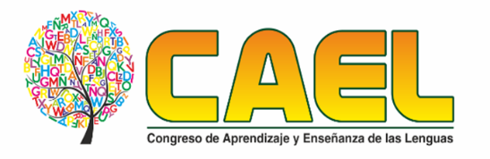


II CONGRESS ON LANGUAGE LEARNING AND TEACHING
PROPOSAL FORM
Proposal Title:

Presenter 1
Name:
Email:
Cell phone Number:
Institution:
Position:
Biodata (50 words maximum):

Presenter 2
Name:
Email:
Cell phone Number:
Institution:
Position:
Biodata (50 words maximum):

Abstract (250 words maximum)

Equipment needed:

Type of presentation: (Final Research report , Ongoing Research report, Research proposal, Report of Innovative Teaching Experiences, Poster session, workshop)

Universidad de Sucre
Sincelejo, Sede Puerta Roja
Email: 2congresolenguas@unisucre.edu.co
TELEFONO: 314 385 73 63
NIT. 892.200.323-9
Sincelejo-Sucre

